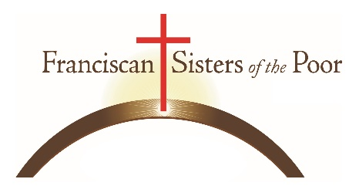Congregational Archivist
The Franciscan Sisters of the Poor are seeking a Congregational Archivist. This position will be located at St. Clare Convent, 60 Compton Road, Cincinnati, Ohio and is a full-time, salary position.
The Archivist administers a fully integrated archives and records management program for the Franciscan Sisters of the Poor, a multicultural and international religious congregation. The Archivist preserves and administers the historic records considered to be of enduring value; develops archival policies and procedures and assists those using the congregational archives. The Archivist manages sensitive and confidential materials relating to legal, financial and administrative functions of congregation and safeguards the confidentiality of information in all aspects of daily duties.
Requirements:
- Bachelor's in Archives or records management with 3 years of experience.
- Excellent verbal/written communication, organizational skills and presentation skills.
- Strong skills with managing digital records, including scanning photographs and documents and basic image editing.
- Understanding of historical and current Catholic tradition.
- Ability to use discretion and commitment to safeguarding confidential information.
Responsibilites include:
- Develops, plans, organizes and maintains the Archives of the Franciscan Sisters of the Poor by regularly reviewing and updating policy and procedures for the Archives according to the professional standards established by the Society of Amercian Archivist.
- Ensure proper preservation of the archival records in a secure, environment.
- Oversee the selection of materials for digitization, the entire digitization process, and the uploading materials to the Congregational database.
- Arranges for regular transfer of inactive records to the Archives according to an approved retention schedule. Provides advice to congregational offices regarding archival records and sets up a a regular program for transfer of records to archives. Develops a process and procedure for retrieval of archival materials from local communities.
- Oversees the documentation and inventorying of the artifact collection
- Engage in planning efforts for the future transition of the archives and work to prepare the collection for its eventual move.
- Update and maintain the information in the selected database software provide an integrated electronic records program.

